**France Fact Sheet**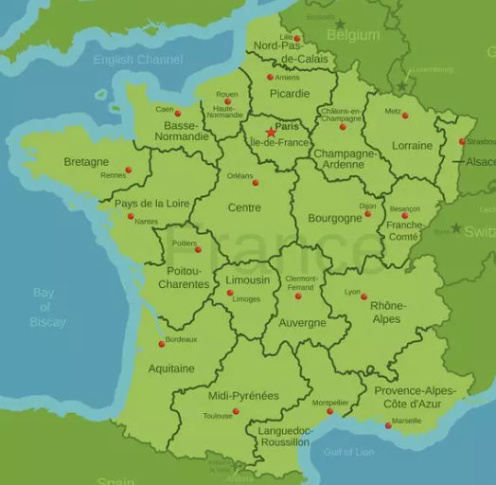

**Capital City: _____________________________**

**Population: _____________________________**

**Currency: _____________________________**

**Language: __________________________**

**Point out on the map, where you’re going Thursday:**

**Surroundings countries: ______________________________________________**



**A Famous Landmark in France (not The Eiffel Tower!)**

**_________________________________________**

**Someone Famous from France (and what she/he is famous of)**

**_______________________________________________________**

**A Typical Dish from France**

**__________________________________________________________**

**3 Facts about France You Didn’t Know**

1. **_______________________________________________________________**
2. **_______________________________________________________________**
3. **_______________________________________________________________**

**PRINT OUT BEFORE CLASS!!**