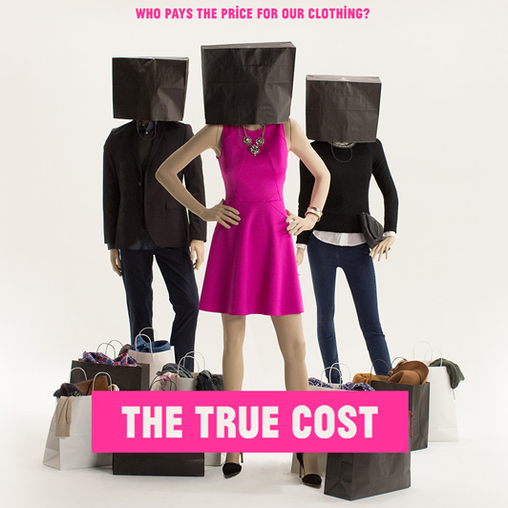
The true cost - weekassignment

Take a look at the poster from the documentary “The true cost”
Describe what you see at the poster
What do you think the film is about?

Look up these terms:
garment
garment worker
living wage
minimum wage
fair trade
sweatshop
supply chain
propaganda
consumer, consumption
disposable
pollution, polluting
developing country
GDP
multinational retailer
human rights
exploitation, exploit
trade union
capitalism
outsourcing

