Nyhedsopgave uge 49

“Zombie minks” in Denmark that were killed to stop spread of coronavirus appear to rise from their graves
https://www.foxnews.com/world/zombie-minks-denmark-killed-covid-19-rise-from-graves
- Read the text together in your group. Take turns reading aloud.
- Why were so many minks buried in mass graves?
- Why did some of the dead minks rise to the surface?
- Where in Denmark is the mentioned mink grave?
- Describe the size of the graves.
- Why did the local people fear pollution from the graves?
- What do authorities plan to do now to fix the problem?
- How many minks were ordered killed in Denmark?
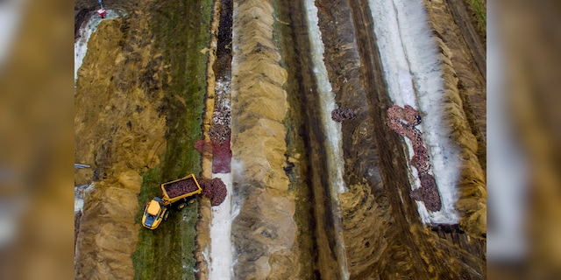
- Describe this picture.
- Was this a correct way of getting rid of all the dead mink?
- Discuss your opinion about animals on Danish farms.
- Should we eat less meat at FE?
- Was it the right decision to kill all mink in Denmark and stop mink farms?

