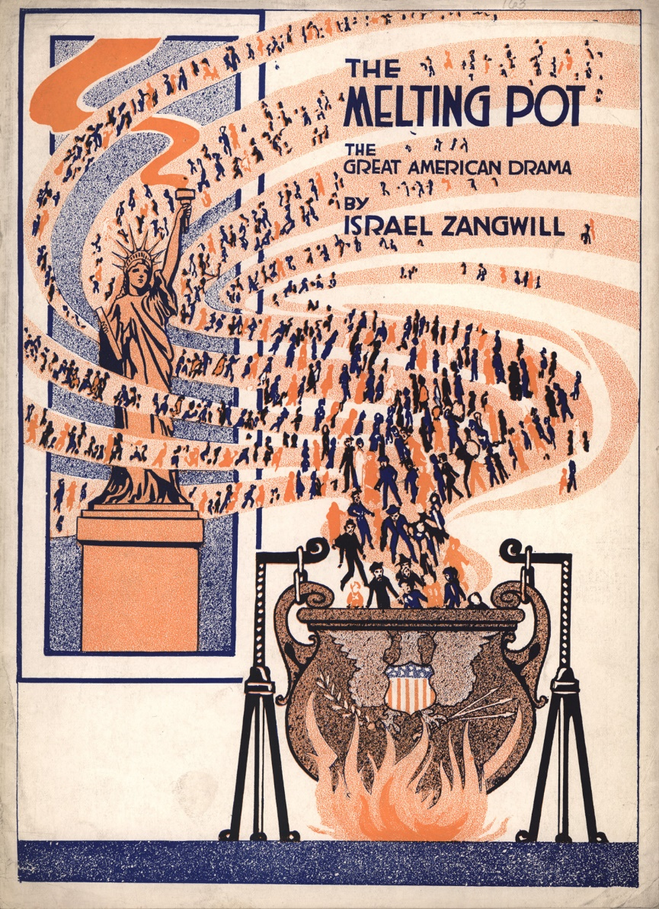
The Melting Pot
The USA has long been known as the melting pot of the world. Here, people and traditions from all over the world come together.
In one house, people will celebrate the Mexican Día de Muertos, and next door, a Muslim Eid, a Chinese New Year, an African-American Kwanzaa, a Jewish Hanukkah, or an Indian Diwali.
But most popular, still, are the traditions brought to America by the Christian European settlers: Valentine's Day, Thanksgiving, Halloween, and Christmas.
To many Americans, Thanksgiving is very important. It is celebrated on the fourth Thursday of November.

Discuss and write down your answers.
- What do you think it means that the US is known as the "melting pot" of the world?
- What are the pros and cons when so many different cultures exist in one country?
- Which positive consequences from integration do you see in our own country?
- Where do we see influence and impact from foreign cultures? Think about sports, food and music.
- Read the text below. Do you think The USA has succeeded their Americanization?
The melting pot theory has been used to describe societies that are formed by an assortment of immigrant cultures that eventually produce new hybrid social and cultural forms. The melting pot theory holds that, like metals melted together at great heat, the melting together of several cultures will produce a new compound, one that has great strength and other combined advantages. While the melting pot theory can be applied to any country that has integrated new cultures into its own, such as Brazil, Bangladesh, or even France, the theory is most commonly used to describe the United States as a new world with a distinct new breed of people amalgamated from many various groups of immigrants. Because of this, the melting pot theory has become synonymous with the process of Americanization. https://onlinelibrary.wiley.com/doi/abs/10.1002/9781444351071.wbeghm359

